I completed the task in the following steps:

#### **1. Project Setup**

* A new Spring Boot project named *LibraryManagement0.1* (to avoid folder conflict with previous *LibraryManagement*) is created using *Spring Initializer*.

#### **2.Dependencies Added in pom.xml:**

* Added the ***Spring Web, Spring Data JPA, and H2 Database*** dependency (Java 17+ compatibility).

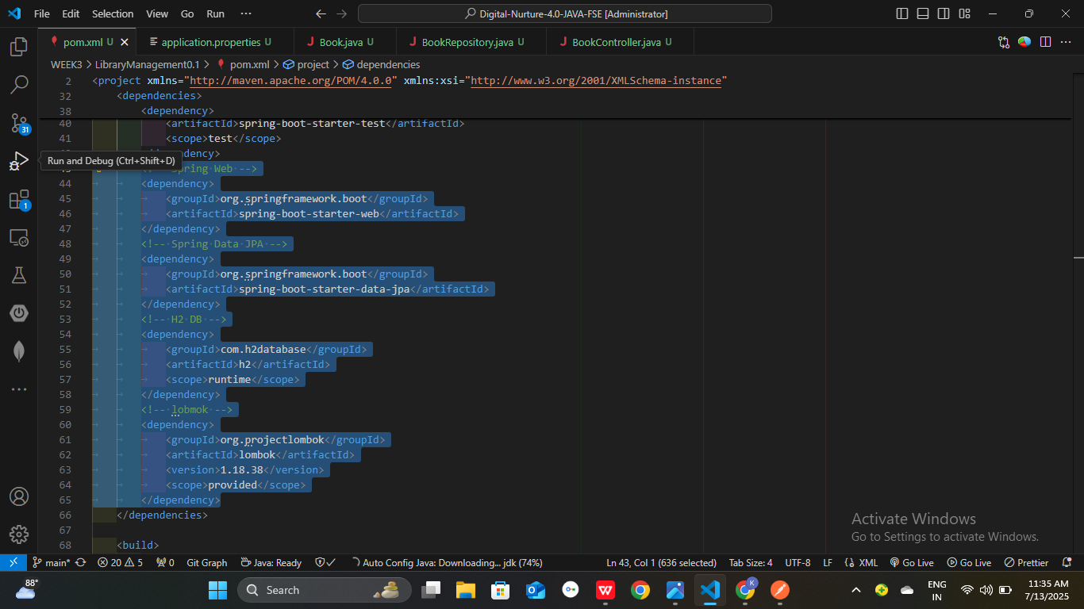

**3.Application Properties Redefined:**

* connection properties added in **application.properties**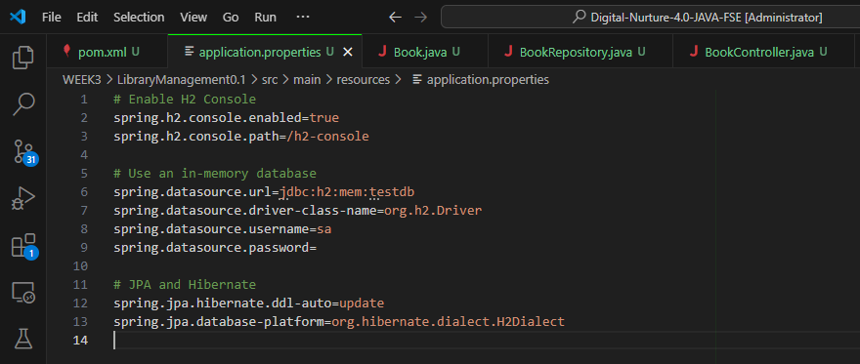

4**. Entities and Repositories:**

* **Book** entity and **BookRepository** interface created inside *com.example.librarymanagement01.entity & repository respectively*.

**5.Create a REST Controller:**

* A **BookController** class is created in

**package com.example.LibraryManagement01.controller**; to handle CRUD operations.

**6. Run the Application:**

* Run the Spring Boot application and test the REST endpoints via POSTMAN.

**Output(Screen shot):**

**➤ Request:**

* Method: POST

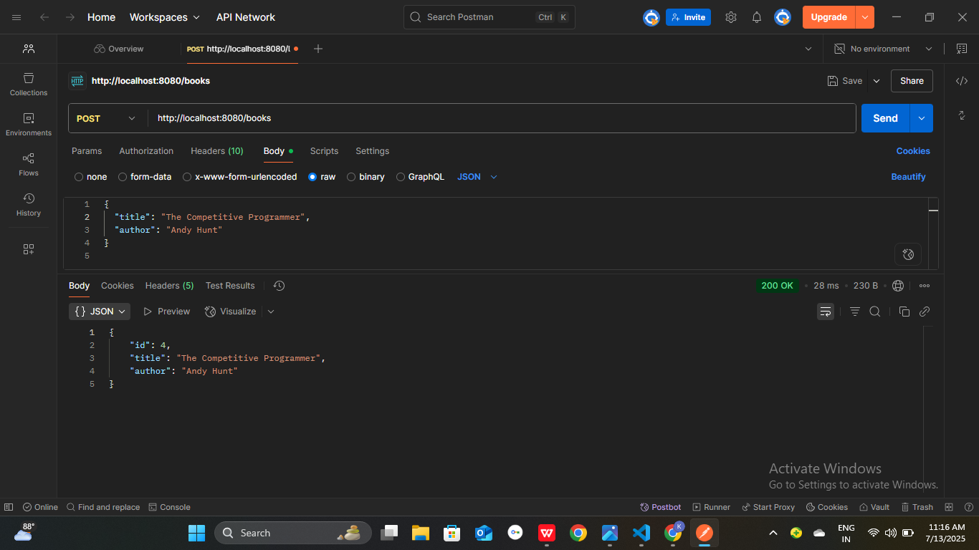

**➤ Request:**Method: GET (all books)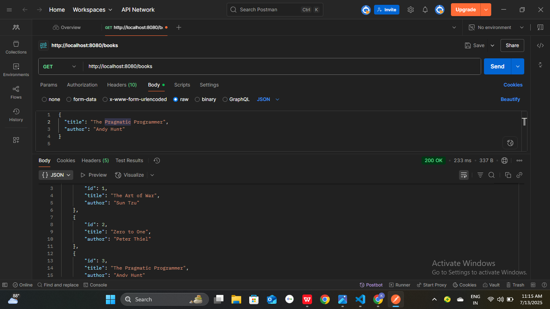

**➤ Request:**Method: GET (by id)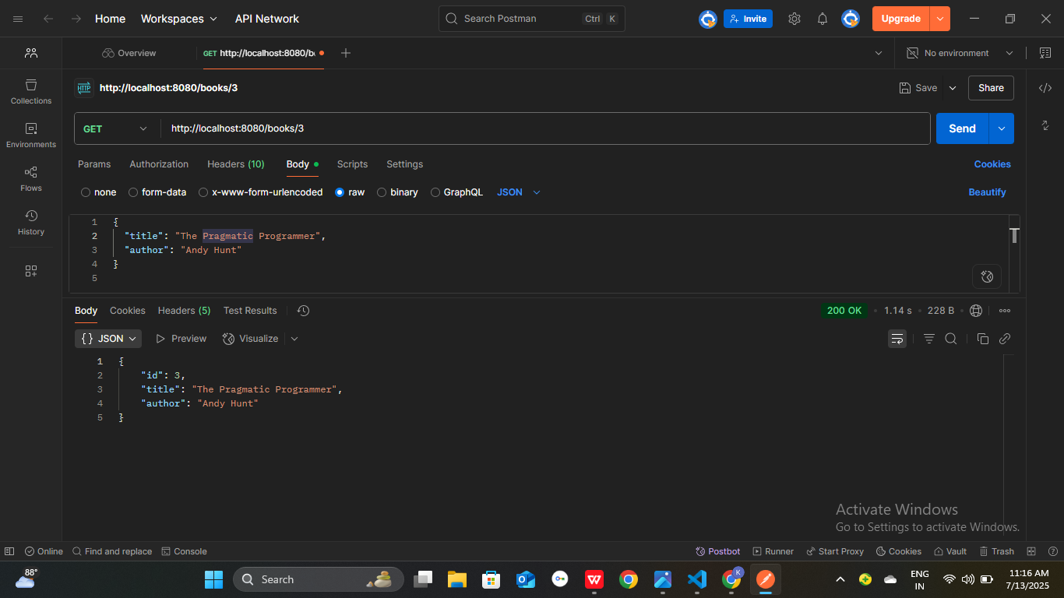

**➤ Request:** Method: DELETE (By id)